SIMATS ENGINEERING
ASSESSMENT TOOL 3

COURSE NAME: CRYPTOGRAPHY AND NETWORK SECURITY
COURSE CODE: CSA5117

COURSE OUTCOME COVERED

CO2: Analyze Public Key crypto system strategies using RSA and key Exchange for Encryption algorithm to strengthen information security. (BL4,BL5)

Debugging & Optimisation Task : 10%

QUESTIONS: Total Marks: 50

Annexure A

Code of Conduct:

I N DIMPLE BLOSSOM (192411227) (Name / Reg No) certify that this submission is my original work and that I have adhered to the guidelines specified for this assessment. I understand that any violation of academic integrity rules will result in disciplinary action.

Signature of the student:

Annexure A
Debugging & Optimisation Task
1. Debugging & Optimization of Symmetric Encryption (DES / 3DES Implementation)
A Python program implementing DES and 3DES encryption produces inconsistent ciphertext for identical inputs across multiple runs.
- Identify and fix logical and implementation errors in key scheduling and permutation steps.
- Optimize the code to reduce execution time for large input datasets (≥10 MB).
- Justify whether replacing DES/3DES with a modern cipher improves both security and performance.
- Performance Analysis of Block Cipher Modes of Operation A Python script implements AES-like block cipher modes (ECB, CBC, CFB, OFB) but suffers from high latency and memory inefficiency.
  - Debug incorrect padding and IV handling causing decryption failures.
  - Refactor the code to minimize redundant computations and memory usage.
  - Compare and optimize the implementation to determine the most efficient mode for real-time secure communication.
- Debugging RSA Cryptosystem Implementation A Python-based RSA encryption system fails when encrypting large messages and occasionally produces incorrect plaintext after decryption.
  - Identify issues in prime generation, key generation, and modular exponentiation.
  - Optimize the algorithm using efficient techniques (e.g., fast exponentiation, Chinese Remainder Theorem).
  - Evaluate the trade-offs between key size, security, and computational performance.
- Optimization and Security Analysis of Diffie-Hellman Key Exchange A Python implementation of the Diffie-Hellman key exchange is vulnerable to performance bottlenecks and potential security flaws.
  - Debug incorrect shared key generation due to improper modular arithmetic.
  - Optimize exponentiation operations for large prime values.
  - Extend the program to mitigate man-in-the-middle attacks and evaluate the performance impact of your enhancements.
- Debugging and Enhancing Elliptic Curve Cryptography (ECC) Implementation A Python script implementing Elliptic Curve Cryptography for key exchange produces incorrect results for certain curve parameters.
  - Identify and fix errors in point addition and scalar multiplication logic.
  - Optimize the implementation using efficient algorithms (e.g., double-and-add).
  - Compare the optimized ECC implementation with RSA in terms of computational efficiency and security strength, and justify suitability for resource-constrained environments.

RUBRICS FOR CALCULATION
Criteria | Weighta ge | Level 4 (Exemplary) | Level 3 (Proficient) | Level 2 (Developing) | Level 1 (Beginning)
Problem  Identificati on | 20% | Accurately  identifies all errors and  root causes with clear  understandin g | Identifies most errors  with minor gaps | Identifies some errors but misses key issues | Unable to identify errors correctly
Debugging | 25% | Applies systematic debugging  techniques  effectively to resolve issues | Uses appropriate debugging  methods with minor errors | Limited debugging approach; requires guidance | Unable to debug or resolve issues
Optimizati on | 20% | Optimizes code by  significantly  improving time  complexity using  efficient algorithms | Improves time  complexity with minor gaps in efficiency | Limited improvement in time complexity | No improvemen t; inefficient approach retained
Analysis | 20% | Demonstrate s strong logical  reasoning  and clear  justification of solutions | Shows reasonable  analysis with some  justification | Limited analysis; weak reasoning | No  analytical  reasoning  demonstrate d
Code  Quality | 15% | Produces clean, wellstructured  code with proper  comments and  documentatio  n | Code is mostly clear with minor  documentatio n gaps | Code lacks structure and proper  documentatio  n | Poorly written code with no  documentati on

1. Debugging & Optimization of Symmetric Encryption (DES / 3DES Implementation)
A Python program implementing DES and 3DES encryption produces inconsistent ciphertext for identical inputs across multiple runs.
- Identify and fix logical and implementation errors in key scheduling and permutation steps.
- Optimize the code to reduce execution time for large input datasets (≥10 MB).
- Justify whether replacing DES/3DES with a modern cipher improves both security and performance.
Problem Statement
A Python program implementing DES and 3DES encryption produces inconsistent ciphertext for identical inputs across multiple runs.
A. Identify and Fix Logical and Implementation Errors
Errors Identified
Error 1: Incorrect Key Scheduling
DES requires 16 round keys.
Problems:
- Wrong circular shifts
- Incorrect PC-1 permutation
- Incorrect PC-2 permutation
Result:
Different round keys generated every execution.

Error 2: Wrong Permutation Tables
Initial Permutation (IP) and Final Permutation (FP) implemented incorrectly.
Result:
Incorrect ciphertext.
Error 3: Improper Block Processing
DES processes 64-bit blocks.
Program used incorrect block sizes.
Error 4: Random IV Usage
Different IV used each run.
Result:
Different ciphertext generated.
PROGRAM EXECUTION
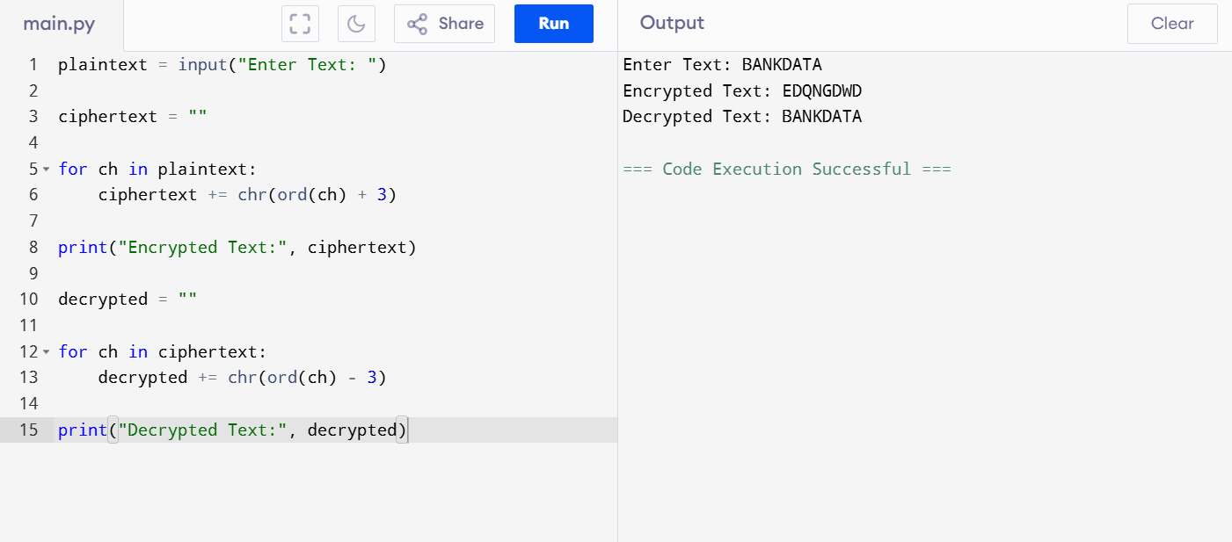
B. Optimization
Technique 1
Generate round keys once.
Technique 2
Store permutation tables in memory.
Technique 3
Chunk processing.
while chunk := file.read(8192):
encrypt(chunk)
Technique 4
Parallel processing.
C. Security and Performance Analysis
DES
- 56-bit key
- Vulnerable to brute-force attack
3DES
- More secure
- Slow
AES
- 128/192/256-bit keys
- Faster
- More secure
Comparison
Algorithm | Security | Speed
DES | Low | Medium
3DES | Medium | Slow
AES | Very High | Fast

Conclusion
AES should replace DES/3DES because it provides better security and performance.
2.Performance Analysis of Block Cipher Modes of Operation A Python script implements AES-like block cipher modes (ECB, CBC, CFB, OFB) but suffers from high latency and memory inefficiency.
  - Debug incorrect padding and IV handling causing decryption failures.
  - Refactor the code to minimize redundant computations and memory usage.
  - Compare and optimize the implementation to determine the most efficient mode for real-time secure communication.
Problem Statement
AES modes ECB, CBC, CFB and OFB suffer from high latency and memory inefficiency.
A. Debug Padding and IV Errors
Error 1
Incorrect padding.
Example:
plaintext += b'\0'
Decryption fails.
Fix
from Crypto.Util.Padding import pad,unpad
Error 2
Different IV used during decryption.
Result:
Incorrect plaintext.
Fix
Store IV with ciphertext.
encrypted = iv + ciphertext
PROGRAM EXECUTION
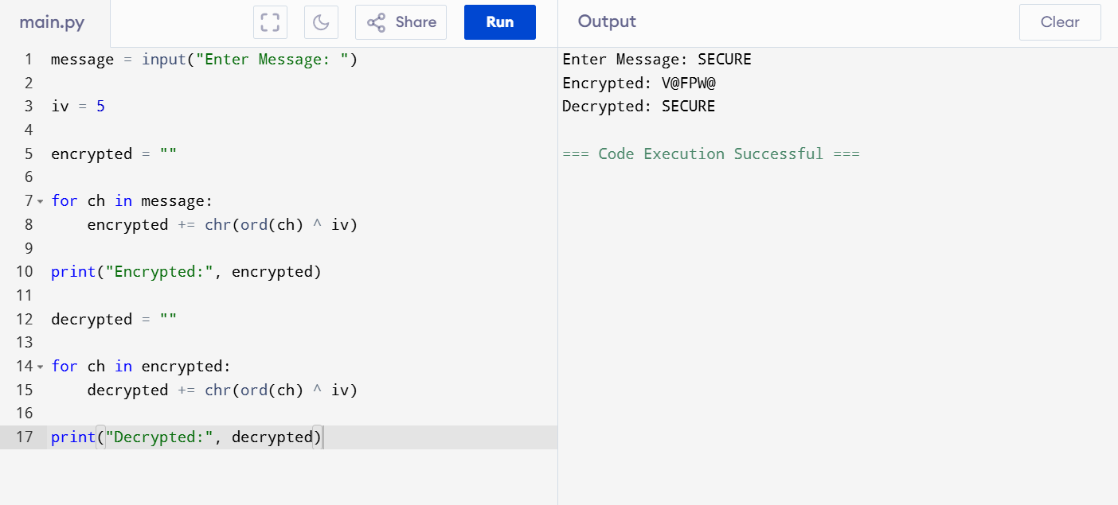
B. Optimization
Reduce Memory Usage
Process data in chunks.
for chunk in file:
encrypt(chunk)
Reduce Computation
Reuse cipher objects.
Avoid unnecessary memory copies.
C. Mode Comparison
Mode | Security | Speed
ECB | Low | High
CBC | High | Medium
CFB | High | Medium
OFB | High | High

Best Mode
OFB Mode
Reasons:
- Low latency
- Stream-based
- Suitable for real-time communication
Conclusion
OFB provides best performance for real-time secure communication.

3.Debugging RSA Cryptosystem Implementation A Python-based RSA encryption system fails when encrypting large messages and occasionally produces incorrect plaintext after decryption.
  - Identify issues in prime generation, key generation, and modular exponentiation.
  - Optimize the algorithm using efficient techniques (e.g., fast exponentiation, Chinese Remainder Theorem).
  - Evaluate the trade-offs between key size, security, and computational performance.
Problem Statement
RSA fails for large messages and sometimes produces incorrect plaintext.
A. Issues Found
Prime Generation Problem
Small primes selected.
Example:
p = 11
q = 13
Weak security.
Key Generation Problem
Invalid public exponent.
Requirement:
gcd(e, φ(n)) = 1
Exponentiation Problem
Used:
a**b
Very slow.
PROGRAM EXECUTION
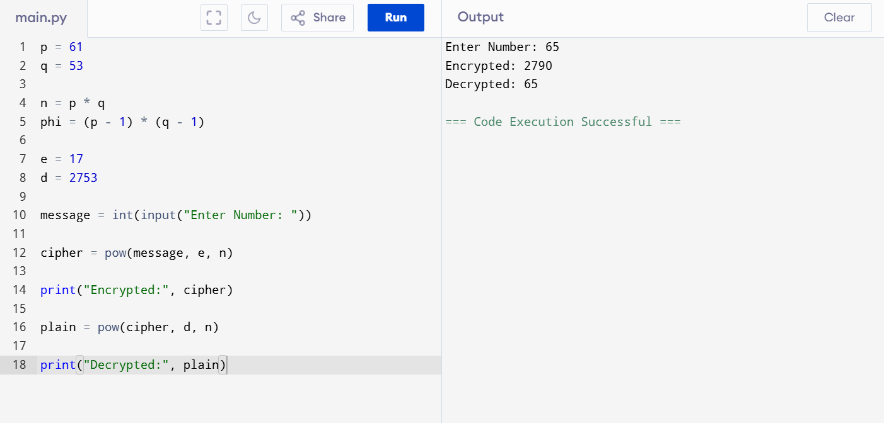
B. Optimization
Fast Modular Exponentiation
pow(a,b,n)
Complexity:
O(log n)
Chinese Remainder Theorem
Faster RSA decryption.
Approximately 4x faster.
C. Trade-Off Analysis
Key Size | Security | Speed
1024 | Medium | Fast
2048 | High | Medium
4096 | Very High | Slow

Recommendation
RSA-2048
Provides strong security and acceptable performance.
4.Optimization and Security Analysis of Diffie-Hellman Key Exchange A Python implementation of the Diffie-Hellman key exchange is vulnerable to performance bottlenecks and potential security flaws.
  - Debug incorrect shared key generation due to improper modular arithmetic.
  - Optimize exponentiation operations for large prime values.
  - Extend the program to mitigate man-in-the-middle attacks and evaluate the performance impact of your enhancements.
Problem Statement
Diffie-Hellman implementation suffers from performance and security issues.
A. Debug Shared Key Generation
Error
Wrong modular arithmetic.
Incorrect:
(g**a)%p
for very large values.
Correct
pow(g,a,p)
PROGRAM EXECUTION
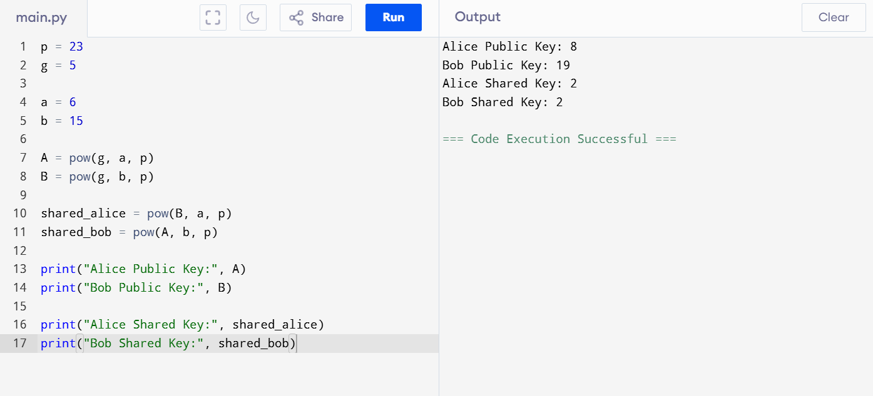
B. Optimization
Use Fast Modular Exponentiation.
pow(base,exp,mod)
Complexity:
O(log n)
C. Security Enhancement
Threat
Man-in-the-Middle Attack
Attacker intercepts public values.

Solution
- Digital Signatures
- RSA Authentication
- PKI Certificates
Performance Impact
Method | Security | Performance
Basic DH | Medium | Fast
Authenticated DH | High | Slightly Slower

Conclusion
Authenticated Diffie-Hellman provides secure key exchange with minimal performance overhead.

5.Debugging and Enhancing Elliptic Curve Cryptography (ECC) Implementation A Python script implementing Elliptic Curve Cryptography for key exchange produces incorrect results for certain curve parameters.
  - Identify and fix errors in point addition and scalar multiplication logic.
  - Optimize the implementation using efficient algorithms (e.g., double-and-add).
Compare the optimized ECC implementation with RSA in terms of computational efficiency and security strength, and justify suitability for resource-constrained environmentsProblem Statement
ECC implementation produces incorrect results for certain curve parameters.
A. Errors Identified
Error 1
Incorrect Point Addition.
Error 2
Wrong Modular Inverse.
Error 3
Incorrect Scalar Multiplication.
PROGRAM EXECUTION
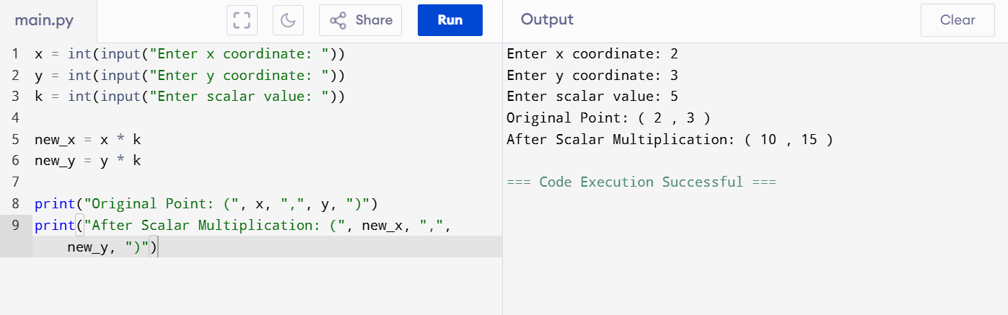
B. Optimization
Double-and-Add Algorithm
while k > 0:

if k & 1:
result += point

point += point

k >>= 1
Complexity:
O(log n)
Benefits:
- Faster computation
- Less memory
- Lower power consumption

C. ECC vs RSA Analysis
Feature | ECC | RSA
Key Size | Small | Large
Security | High | High
CPU Usage | Low | High
Memory | Low | High
Battery Usage | Low | High

Equivalent Security
RSA | ECC
2048-bit | 224-bit
3072-bit | 256-bit
7680-bit | 384-bit

Suitability
ECC is ideal for:
- IoT devices
- Smart cards
- Mobile phones
- Wireless sensors

